PLEASE PRAY FOR THOSE WHO ARE SICK OR HOMEBOUND
James Edward Adams, Kathryn Barczak, James Bauer, Patricia Bauer, Deacon Bruce Becker, Sally Becker, Galynn Brady, Sister Carol Jean Czyrnik, Alicia Junghans, Tyler McKinley, Rick McKinley, Rowen Ream, Alexandra Rice, Carly Rice, Doug Rice, Rose Rice, Gary Singel, Betty Spisak, Joanna Stone, Carol Sobecky, Leona Sutt, Joe Torchia, David Watson, Sheila Weppner, Mark Wojno, Nancy Wojno, Faryn Wolff.
===========================================================================
SALUTE TO THOSE SERVING IN THE MILITARY AND A REMEMBRANCE IN OUR PRAYERS
May God bless these brave men and women who serve God and Country.
Ensign Adam Guarno, USCG; Master at Arms 2nd Class Izeke W. Pinkas, Fallon, NV; Lt. Col. Joshua P. Higgins, US Army; Lt. Col. Melinda Rovan Corallo, Travis Air Force Base, California; PFC; Lance Corporal Jacob Taylor, USMC; Private 1st Class Zack Taylor, US Army; Trista L. Urban, PFC, Army National Guard; Jared N. Dull, HM3, US Navy, Quantico, Va.; Stefanie Kollar, TSgt. Air Force, Hurlburt Field, Fort Walton Beach, Fla., Fr. Don Fullerton, USS Enterprise, Sgt. Bryan Maxwell Porath, Major Aaron Donahey, US Army, Fort Moore, Savannah, GA.; Petty Officer 1st Class Heather L. Dovala, Great Lakes, IL.; Sgt. Jarod Pisarchik, Army National Guard; LCDR Kara Yingling, San Diego; LCDR Shannon Yingling; Tech Sgt. Devon Gilbert, Offutt Air Force Base, Nebraska; Senior Airman Daniel Christner, USAF, 193rd Special Operations Wing; Lt. Col Steven Thomas, USAF, deploying to the Middle East; Major Colin Harrington, US Army, Bethesda, MD; 2nd Lt. Ryan Powers, USMC, Camp Lejeune, NC; Senior Airman Anthony Rosage, USAF; Fort Gordon, GA; Capt. Kenneth Yacynych, US Army, Fort Hood; SSgt Eliott Mulvehill, USMC, Birmingham, AL.; 1st Lt. Kasey Meredith, USMC, Camp Lejeune, NC; Cpl. Aunna Yingling, US Army; Petty Officer 2nd Class, Gage Pollino, US Navy; Pvt. 1st Class Daylee Ragno, US Army, E-3 Paratrooper, Fort Bragg, NC; SPC Morgan Rullo, ARNG Camp Buehring, Kuwait; Fr. William Appel, Navy Chaplain; Jonathan McClain, Warrant Officer, U.S. Army, Fort Drum, NY; Tech Sgt. Daniel Bracken; Senior Airman Jeremy Williams
To add a name to our Salute to those in the Military, please call 539-1632. If a person is no longer serving on active or reserve duty, please call the Parish Office to remove his/her name.
__________________________________________________________________________________________________________________________________________________
A PRAYER FOR OUR DEPLOYED MILITARY: Heavenly Father, inspire those who are overseas for the cause of peace. Send Your Son, Jesus Christ, as the Prince of Peace. Bless the men and women of our military who respond to the needs of peacekeeping. Keep them safe from harm. Let them be models of discipline and courage and bring them home safely to their loved ones. We ask this in Your Name. Amen.
Did you know that it is a custom in Johnstown to wear something RED on Fridays to honor our military?
=============================================================================
COMMUNITY NEWS

PRO LIFE VIGIL – is held weekly on Thursday, at 11:00AM across from the Planned Parenthood on Franklin Street in Johnstown.


PRAYER FOR OUR NATION — God our Father, Giver of Life, we entrust the United States of America to Your loving Care. You are the rock on which this nation was founded. You alone are the true source of our cherished rights to life, liberty and the pursuit of happiness. Reclaim this land for Your Glory and dwell among Your People. Send us Your Spirit to touch the hearts of our nation’s leaders. Open their minds to the great worth of human life and the responsibilities that accompany human freedom. Remind Your people that true happiness is rooted in seeking and doing Your will. Through the intercession of Mary Immaculate, Patroness of our land, grant us the courage to reject the “culture of death.” Lead us into a new millennium of life. We ask this through Christ Our Lord. Amen.

November 2, 2025
The Commemoration of All Faithful Departed
The Faith Community of
St. Francis of Assisi
Mission Statement: St. Francis of Assisi is a Roman Catholic worshipping Community of Faith, dedicated to the concept of putting “Christ first” in our hearts, lives, family and community, with the hope that our world can become a better place and that we can all be made worthy to enter into the Kingdom of God. Our ministry is centered on the Sacraments and our acts of Faith, Hope and Charity.

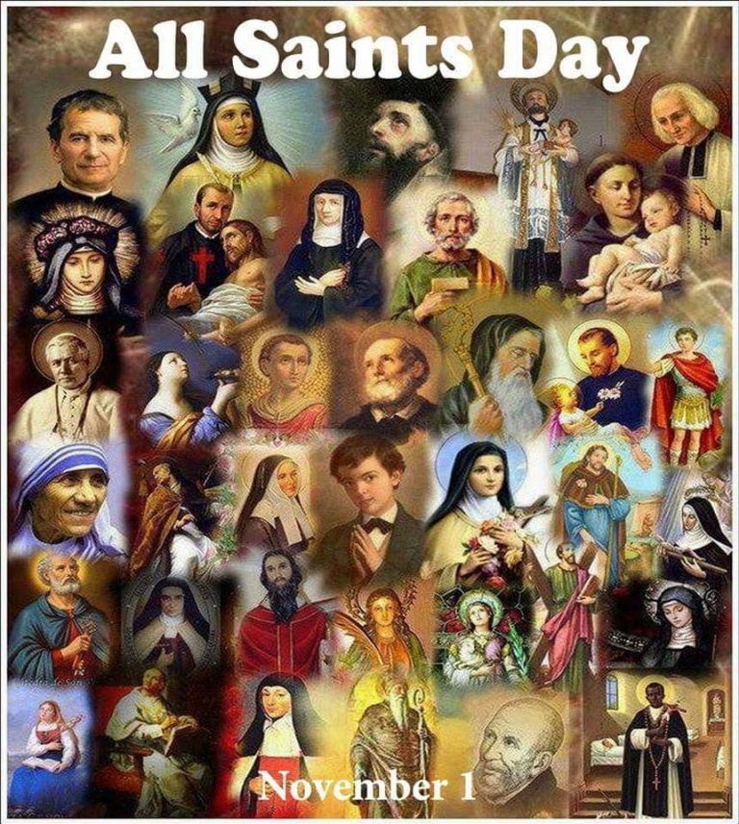
Pastor – Fr. Anthony Francis Spilka, OFMConv.;
Permanent Deacon Bruce Becker
St. Francis of Assisi, 120 Barron Avenue
Johnstown, PA 15906
Rectory Phone – 814-539-1632
Activity Center – 814 – 539-3518
Fax: 814 – 539-5888 Email – sfassisich@atlanticbbn.net
Facebook – St Francis of Assisi Church
Oremus Ministry (Prayer Chain) – 814-539-1632
Web Site: http://www.stfrancisofassisijtown.com
Parish Secretary – Megan Billow
Office Hours – 9:00 AM to 2:45 PM – Mon. thru Thurs.
Parish Council President – Mary Frances King
Finance Council President – Teresa Thompson
Cemetery Council President - William Heim – 254- 2942
Men’s Club President – John Davis
Rosary Society – Cecilia Neiderer
Gabriel Project – 814-418-1813
DRE — Deacon Bruce Becker
MASS SCHEDULE – Monday – 9:00AM, Tuesday – 6:15PM, Wednesday – Saturday – 9:00AM
Saturday Vigil– 4:00PM, Sunday – 7:30AM & 9:30AM — Holy Day – 5:30 PM

Alternative to Abortion – Precious Life Inc. (814)269-4391; Domestic Violence Hotline – Victim Services (814)288-4961; Suicide Prevention Hotline – (814)535-8531 or 1-877-268-9463; St. Vincent DePaul (814)535-8521

Baptism – Parents are expected to be registered members of the Parish and to attend a class for new parents in preparation for the Baptism of their child. It is encouraged that this be done prior to the birth of the child. Please call the Rectory to make early arrangements.
Reconciliation – The Sacrament of God’s merciful love and compassion is celebrated Tues at 5:45 PM and Sat 3:15 PM at St. Francis of Assisi. Communal Penance Services - Advent and Lent.
Anointing of the Sick Communal Celebration 2nd Sunday of Advent and 3rd Sunday of Lent.
Marriage in accordance with Diocesan directives, arrangements must be made at least 9 months before the marriage date. All couples are required to attend Diocesan sponsored Pre-Cana sessions and to participate in the FOCCUS inventory. Call the Rectory for information and schedules.
Christian Initiation (OCIA) – Those who are interested in becoming Catholic, as well as those who are interested in learning more about their Catholic Faith, may call the Parish office for more information.
Parish Membership – We are always happy to welcome new parishioners. You may register at the Parish Office. Registration, the practice of stewardship (the regular use of envelopes) and regular participation in the Eucharist
indicates active membership and eligibility to act as a Godparent or Sponsor. Your stewardship of time, treasure and talent is essential for the common good and provides a stable income for the Parish, enabling us to prepare a budget.
Ministry to the Sick - If you or someone you know are unable to attend Mass and would like to receive the Sacrament of Penance or Holy Eucharist please contact the Parish Office to schedule a visit.
First Friday – Adoration of the Blessed Sacrament from 9:30AM – 12 Noon followed by Benediction
Rosary Society – First Monday of the Month – 3:00PM in the Church
Men’s Club – First Thursday of the Month – 6:30PM in the Activity Center
PARISH OFFICE – Will be closed on Monday, November 10th in observance of Veteran’s Day!

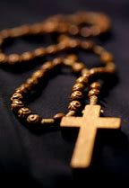
CONGRATULATIONS – Congratulations on the Baptism of Luke Ashton Gregorchik and her parents, John and Leah, and Godparents, Brandon and Kimberly.

ROSARY SOCIETY – Will be on Monday, November 3rd at 3:00PM. Please consider joining us for Rosary, Reflection and Benediction of the Blessed Sacrament.

OUR ANNUAL JOE BARTKO MEMORIAL FOOD DRIVE – Non-perishable food and household items collection for the Joe Bartko Memorial, St. Vincent De Paul Food Kitchen is beginning. Parishioners are asked to share their bounty from God with those less fortunate. Monetary donations will also be accepted and may be placed in the envelope included in the bulletin. Donations should be non-perishable and NO glass containers. Suggested items include canned vegetables, pasta, cereal, tuna, soup, stuffing mix, cake mix, salt, pepper, paper products (paper towels, toilet paper, napkins, etc.). Please use the bag provided in the vestibule for your donations. The collection will end Sunday, November 23rd.

DONATIONS OF BASKETS OR ITEMS FOR BASKETS NEEDED – Baskets or items for baskets are needed for our Music Bingo prior to November 8th. Donations can be left in the Chapel Area of the Church or contact Carolyn at (814)421-6016. Help us make this a huge success!

PUBLIC ROSARY – Praying for Our Veterans & Our Country! Thursday, November 13th at 6:30PM at St. Clement Church on Saturday, November 15th at 12 Noon in Downtown Johnstown on Vine St. Parklet Behind the Crown American Building.

VETERAN’S DAY CELEBRATION AT ST. CLEMENT’S PARISH — Honoring All Who Served!
114 Lindberg Avenue, Saturday, November 8th at 4:00 PM Mass. A Special Liturgy has been planned to celebrate and honor the men and women who have made sacrifices in the name of freedom and democracy. We ask you to pray for all members of the armed forces, especially those who are serving from our parish and hope you will join us in honoring all who have served. Reserved seating will be available for veterans, active military, and their families. We encourage you to wear your unform or RED, WHITE & BLUE A special collection will be taken up for VETERAN COMMUNITY INITIATIVES.

The Sanctuary Candle will burn for the month of November for – Special Intentions for two Dear Friends.

The Blessed Mother Candle will burn for the month of November for Special Intention – From: Kathy Zierer

CONTRIBUTIONS LAST WEEK – Loose – $169.00; Adults – $2,228.20; Monthly – $35.00; Candles – $194.00; St. Vincent DePaul – $235.00; All Saints – $5.00; All Souls – $32.00; Retired Priest Medical – $10.00; Cemetery – $215.00; Online Giving - $235.00 — Total Collection - $3,358.20

SITTING BULLS SLED HOCKEY – Hockey for Physically Challenged Athletes, will hold a BINGO BONANZA at St. Francis Church Hall, 120 Barron Ave. Johnstown, Pa. 15906, on Saturday, November 15. Doors open at 11:30 AM, with Regular Games beginning at 1:00 PM. 15 Regular Games, Winner Total $40 per game; 2 Special Games, Winner Total $50 1st Part, $150 2nd Part; Fast Bingos, Winner Total $100 per game; Jackpot Game, Winner Total $300 Plus. Pull Tabs, 50/50 and Basket Raffle will be available. Light refreshments included. Donation $25.00 entry.

BACKGROUND ON THE GOSPEL READING

On the Feast of All Souls, we pray for the souls of all those who have died. There are many choices of readings for this day, all focusing on our belief in the resurrection of the dead and Jesus' promise of eternal life. The Gospel story of the raising of Lazarus offers us many important insights about this aspect of our faith.
Jesus was good friends with Lazarus and his sisters, Martha and Mary. Lazarus had fallen ill, and Martha and Mary had sent word to Jesus. Jesus delays his journey to them, however, and when he arrives in Bethany, he finds that Lazarus is dead and has been buried for four days.
The scene described at Bethany is a sad one; Lazarus and his family have many friends who have come to mourn his death. Martha goes out to meet Jesus when he arrives. She cries with him, saying that if Jesus had been there, Lazarus would not have died. Yet she remains confident that God will do whatever Jesus asks. Jesus consoles her with the promise that Lazarus would rise from the dead. Martha affirms her belief that there will be resurrection of the dead in the last days. Jesus promises her even more; he says that he himself is the Resurrection and the life for all those who believe in him. Martha professes her faith in this, acknowledging that Jesus is Christ, the Son of God.
This is the profession of faith we continue to make, and it is the promise on which we base our hope for eternal life for ourselves and for all those who have died. In his death and Resurrection, Jesus has conquered death for all those who believe in him.
We believe that we continue to share a relationship with those who have died. When we pray for the souls of the faithful departed, we are praying for those whose souls are journeying through purgatory, being prepared for eternal life in heaven. We believe that our prayers for them will help to speed their journey to eternal life with God in heaven.

NOVEMBER 2, 2025 — THE COMMEMORATION OF ALL THE FAITHFUL DEPARTED (ALL SOULS DAY)

On this sacred day, the Church invites us to remember and pray for all the faithful departed – those who have gone before us marked with the sign of faith. It is a day of profound connection, when the veil between heaven and earth feels especially thin.
Stewardship is rooted in gratitude, and today we give thanks for the lives of those who shaped our faith, nurtured our families, and built our communities. Their legacy is a gift we have received, and we are called to be faithful stewards of that gift by living lives of holiness, generosity and love.
As we celebrate this day, we are reminded that stewardship is not only about what we do with our time, talent and treasure – it is about how we care for the memory and spiritual well-being of others. Our prayers for the dead are acts of mercy, expressions of hope, and signs of our belief in the communion of saints. Let us honor the faithful departed by continuing their good works, supporting our parish communities, and living as witnesses to the Resurrection.

